**CHAPTER 1**

LOAD FREQUENCY CONTROL IN A SINGLE AREA POWER SYSTEM.

##### INTRODUCTION

Power system is used for the conversion of natural energy to electric energy. For the optimization of electrical equipment, it is necessary to ensure the electric power quality. It is known three phase AC is used for transportation of electricity. During the transportation, both the active and reactive power balance must be maintained between the generation and utilization AC power. When either frequency or voltage changes equilibrium point will shift. Good quality of electrical power system means both the voltage and frequency to be fixed at desired values irrespective of change in loads that occurs randomly. It is in fact impossible to maintain both active and reactive power without control which would result in variation of voltage and frequency levels. To cancel the effect of load variation and to keep frequency and voltage level constant a control system is required. Though the active and reactive powers have a combined effect on the frequency and voltage, the control problem of the frequency and voltage can be separated. Frequency is mostly dependent on the active power and voltage is mostly dependent on the reactive power. Thus, the issue of controlling power systems can be separated into two independent problems. The active power and frequency control are called as load frequency control (LFC). The most important task of LFC is to maintain the frequency constant against the varying active power loads, which is also referred as un- known external disturbance.

Power exchange error is an important task of LFC. Generally, a power system is composed of several generating units. To improve the fault tolerance of the whole power system, these generating units are connected through tie-lines. This use of tie-line power creates a new error in the control problem, which is the tie-line power exchange error. When sudden change in active power load occurs to an area, the area will get its energy through tie-lines from other areas. Eventually the area that is subject to the change in load should balance it without external support. Or else there will be economic conflicts between the areas. This is why each area requires separate load frequency controller to regulate the tie line power exchange error so that all the areas in an interconnected system can set their set points differently. In short, the LFC has two major duties, which are to maintain the desired value of frequency and also to keep the tie line power exchange under schedule in the presence of any load changes. Also, the LFC has to be unaffected by unknown external disturbances and system model and parameter variation.

##### 1.1.1 REASONS FOR THE NEED OF MAINTAINING CONSTANT FREQUENCY:

* The speed of a.c. motors are directly related to the frequency.
* If the normal operating frequency is 50 Hz and the turbines run at speeds corresponding to frequencies less than 47.5 Hz or above 52.5 Hz, then the blades of the turbines may get damaged.
* The operation of a transformer below the rated frequency is not desirable. When frequency goes below rated frequency at constant system voltage then the flux in the core increases and then the transformer core goes into the saturation region.
* Loads and other electrical equipment are usually designed to operate at a particular frequency. Off-nominal frequency operation causes electrical loads to deviate from the desired output. The output of power plant auxiliaries like pumps or fans may reduce, causing reduction in power plant output.

##### 1.1.2 LOAD FREQUENCY CONTROL:

If the system is connected to numerous loads in a power system, then the system frequency and speed change with the characteristics of the governor as the load changes. If it’s not required to maintain the frequency constant in a system then the operator is not required to change the setting of the generator. But if constant frequency is required the operator can adjust the velocity of the turbine by changing the characteristics of the governor when required. If a change in load is taken care by two generating stations running parallel then the complex nature of the system increases. The ways of sharing the load by two machines are as follow:

1. Suppose there are two generating stations that are connected to each other by tie line. If the change in load is either at A or at B and the generation of A is regulated so as to have constant frequency then this kind of regulation is called as **Flat Frequency Regulation.**
2. The other way of sharing the load is that both A and B would regulate their generations to maintain the frequency constant. This is called **parallel frequency regulation.**
3. The third possibility is that the change in the frequency of a particular area is taken care of by the generator of that area thereby maintain the tie-line loading. This method is known as **flat tie- line loading control**.
4. In **Selective Frequency control** each system in a group is taken care of the load changes on its own system and does not help the other systems, the group for changes outside its own limits.
5. In **Tie-line Load-bias control** all the power systems in the interconnection aid in regulating frequency regardless of where the frequency change originates.

##### MATHEMATICAL MODELLING OF A LFC SYSTEM:

##### 1.2.1 MATHEMATICAL MODELLING OF A GENERATOR:

With the use of swing equation of a synchronous machine to small perturbation, we have

$$\frac{2H }{ω}\frac{d^{2}∆δ}{dt^{2}}=ΔPm – ΔP_{e} (2.1)$$

Or in terms of small change in speed

$$\frac{d∆\frac{ω}{ωs}}{dt}=\frac{1}{2Hs}\left(ΔPm \left(s\right)- ΔP_{e} \left(s\right)\right) (2.2)$$

Laplace Transformation gives,

$$∆Ω\left(s\right)=\frac{1}{2Hs}\left(ΔPm \left(s\right)- ΔP_{e} \left(s\right)\right) (2.3)$$

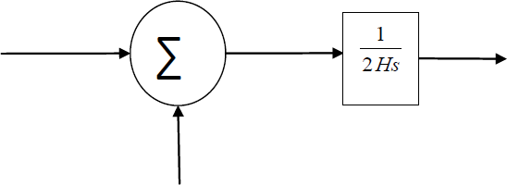

Fig 2.1: Mathematical modelling block diagram for a generator.

##### MATHEMATICAL MODELLING OF LOAD:

The load on a power system consists of variety of electrical drives. The load speed characteristic of the load is given by:

ΔPe = ΔPL + D Δω (2.4)

where ΔPL is the non-frequency sensitive change in load, DΔω is the load change that is frequency sensitive.

D is expressed as percentage change in load divided by percentage change in frequency.

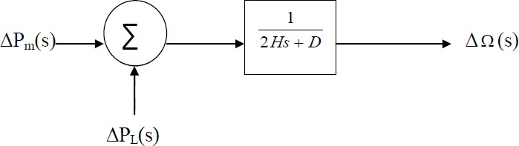

Fig 2.2: Mathematical modelling Block Diagram of Load.

##### 1.2.3 MATHEMATICAL MODELLING FOR PRIME MOVER:

The source of power generation is the prime mover. It can be hydraulic turbines near waterfalls, steam turbine whose energy come from burning of coal, gas and other fuels. The model of turbine relates the changes in mechanical power output ΔPm and the changes in the

steam valve position ΔPV.

GT. (2.5)

where the turbine constant is in the range of 0.2 -2.0.

##### 1.2.4 MATHEMATICAL MODELLING FOR GOVERNOR:

When the electrical load is increased suddenly then the electrical power exceeds the input mechanical power. This deficiency of power in the load side is compensated from the kinetic energy of the turbine. Due to this reason the energy that is stored in the machine is decreased and the governor sends signal for supplying volumes of water, steam or gas to increase the speed of the prime mover to compensate deficiency in speed.

$∆P_{g}=∆P_{ref}-\frac{1}{R}∆f.$ (2.6)

The command ΔPg is transformed through amplifier to the steam valve position command ΔPV. We assume here a linear relationship and considering simple time constant we get this s-domain relation.

$∆P_{v}=\frac{1}{1+τs}{∆P}_{g}\left(s\right).$ (2.7)

Combining all the above block diagrams, for an isolated area system we get the following:

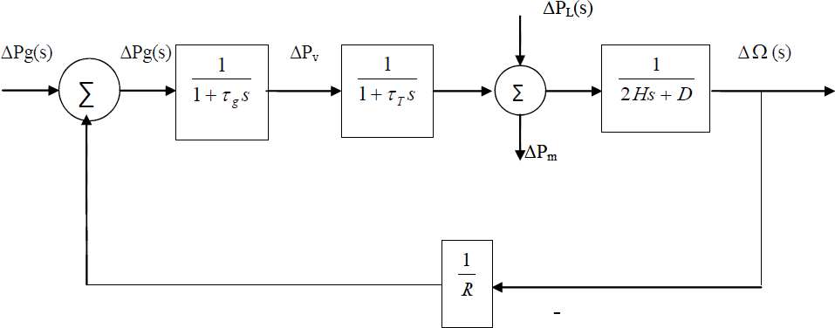

Fig 2.5: complete block diagram of single area system.

The closed loop transfer function that relates the load change $∆P_{L}$ to the frequency deviation $∆Ω$ is

$$\frac{∆Ω(s)}{-∆P_{L}}=\frac{(1+τ_{g}s)(1+τ_{T}s)}{(1+τ_{g}s)(1+τ_{g}s)(2Hs+D)+1/R} (2.8)$$

##### AUTOMATIC GENERATION CONTROL:

If the load on the system is suddenly increased, then the speed of the turbine drops before the governor could adjust the input of the steam to this new load. As the change in the value of speed decreases the error signal becomes lesser and the position of the governor and not of the fly balls gets nearer to the point required to keep the speed constant. One way to regain the speed or frequency to its actual value is to add an integrator on its way. The integrator will monitor the average error over a certain period of time and will overcome the offset. Thus, as the load in the system changes continuously the generation is adjusted automatically to restore the frequency to its nominal value. This method is known as automatic generation control. In an interconnected system consisting of several areas, the task of the AGC is to divide the load among the system, stations and generators so to achieve maximum economy and uniform frequency.

##### 1.3.1 AGC IN A SINGLE AREA:

With the main LFC loop, change in the system load will result in a steady state frequency deviation, depending on the speed regulation of the governor. To reduce the frequency deviation to zero we need to provide a reset action by using an PI controller to act on the load reference setting to alter the speed set point. This PI controller would make changes that the final frequency deviation to become zero. The PI controller gain need to be adjusted for obtaining satisfactory transient response.

The closed loop transfer function of the control system is given by:

$\frac{∆Ω(s)}{-∆P_{L}}=\frac{(1+τ_{g}s)(1+τ_{T}s)}{(1+τ_{g}s)(1+τ_{g}s)(2Hs+D)+K_{P}K_{I}+1/R}$ (2.8)

##### FREQUENCY RESPONSES OF LFC SYSTEM:

An isolated power station has the following parameters Turbine time constant = 0.5 s

Governor time constant = 0.2 s Governor inertia constant = 5 s Governor speed regulation = R per unit

The load varies by 0.8 per cent for a 1 per cent change in frequency (D=0.8)

The governor speed regulation is set to R = 0.05 per unit. The turbine rated output is 250 MW at nominal frequency 50 Hz. A sudden load change of 50 MW (𝝙PL= 0.2 Per unit) occurs.

Find steady state Frequency deviation in Hz. Also obtain time domain performance specifications and the frequency deviation step response.

##### FREQUENCY RESPONSE WITHOUT THE PI CONTROLLER:

To obtain the time domain specifications and the step response following command is used: Pl= 0.2; num= [0.1 0.7 1];

den= [1 7.08 10.56 20.8];

t= 0:.02:10;

c= -pl* step (num, den, t);

plot (t, c), xlabel (‘t, sec’), ylabel(‘pu’); title (‘Frequency deviation step response’);

grid timespec (num, den);

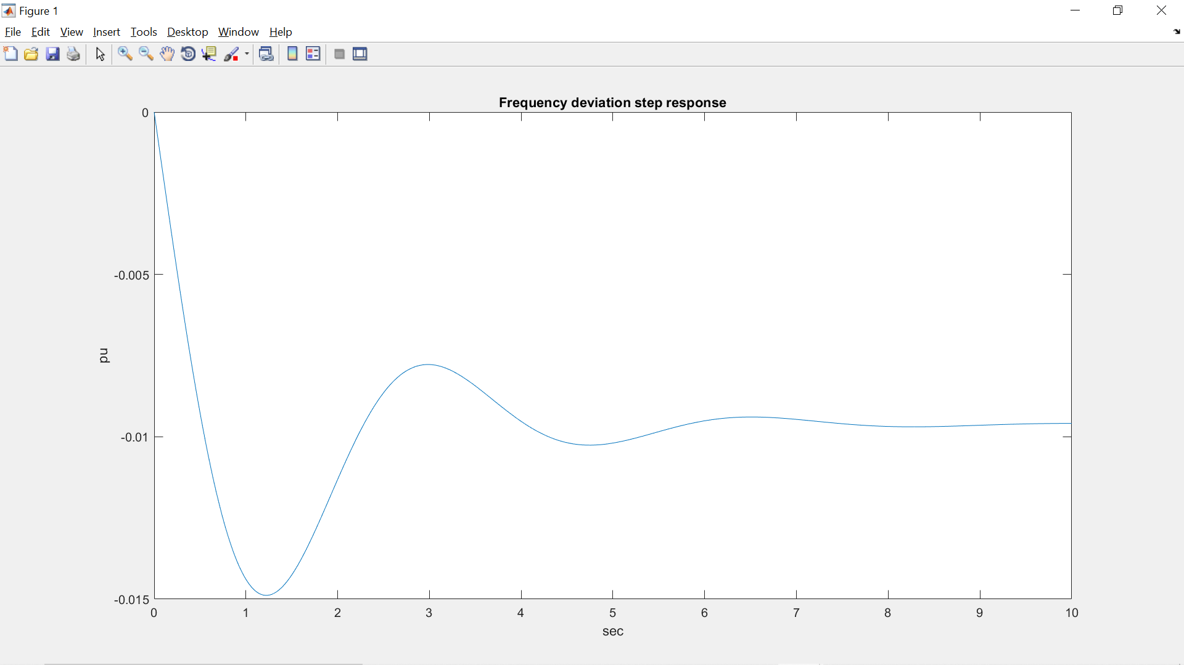

Fig 1.4.1 Frequency deviation step response without using PI controller.

The time domain specifications are:

Peak time= 1.223 Percentage overshoot= 54.80

Rise time= 0.418

Settling time= 6.8

The Simulink model for the above system is:

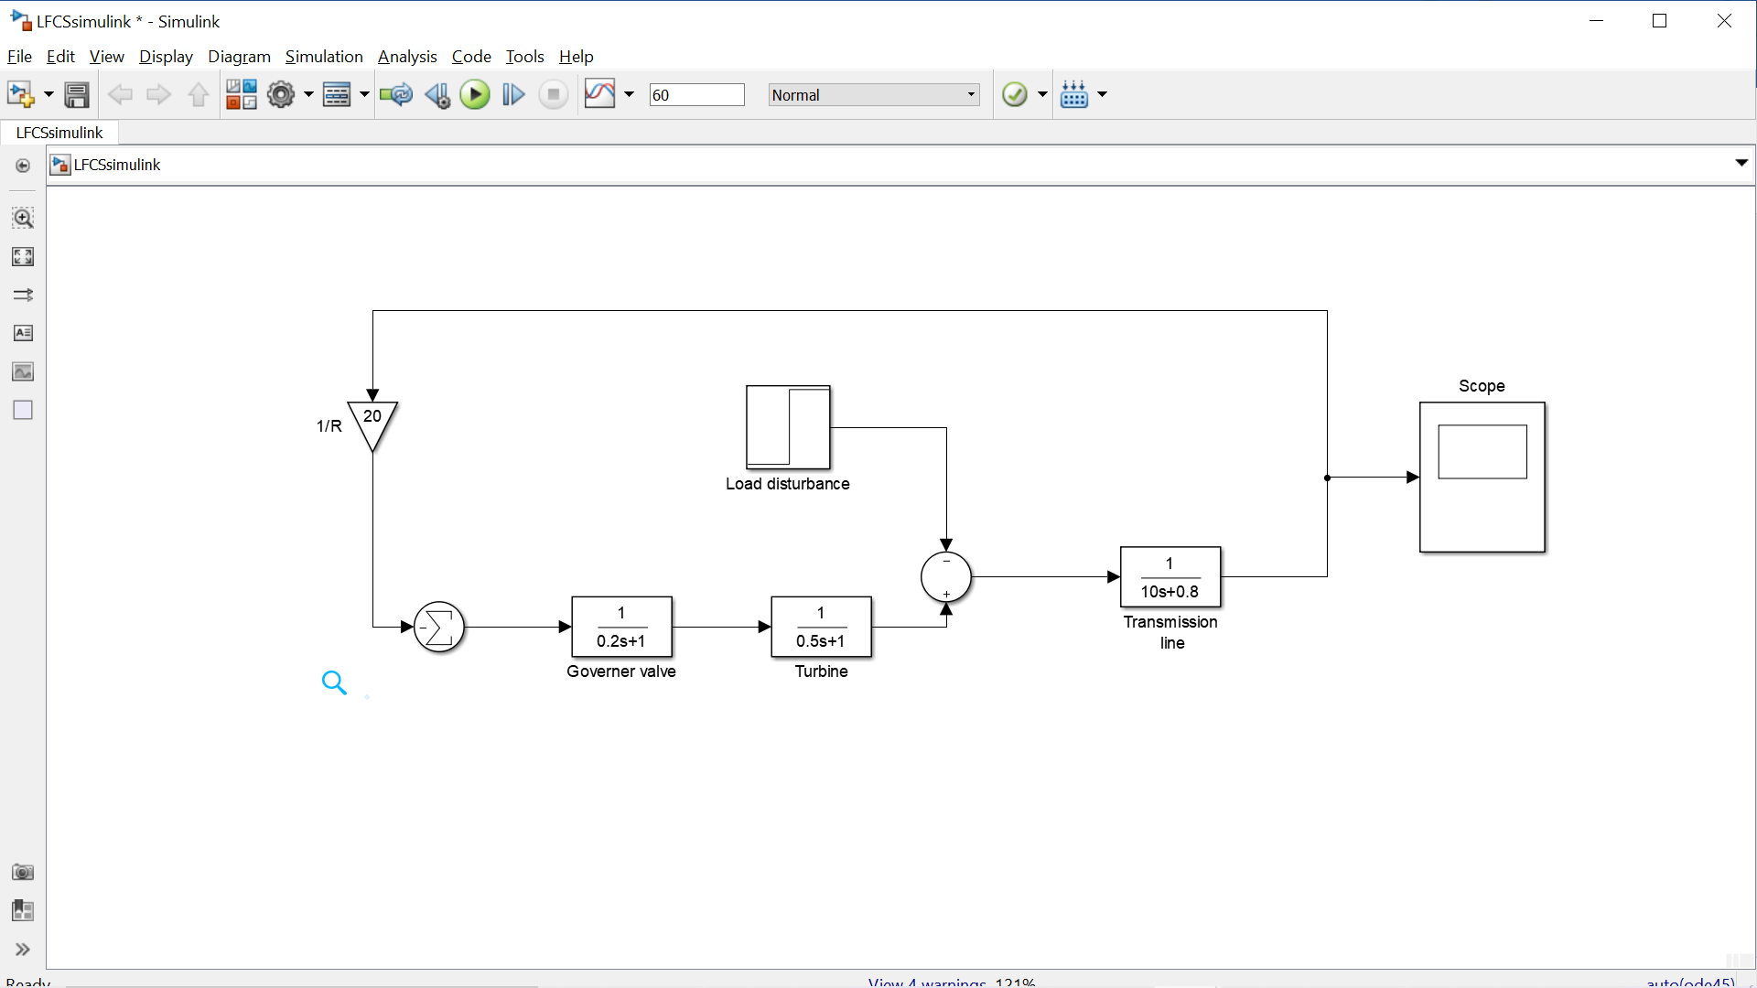

Fig 1.4.2 Simulation Block Diagram of the system without using PI controller.

##### FREQUENCY RESPONSE WITH THE PI CONTROLLER:

Substituting the system parameters, we get the closed loop transfer function as: T(s)= (0.1s3+ 0.7s2+ s)/ (s4+ 7.08s3+ 10.56s2+ 20.8s+ 7)

To find the step response following command is used:

pl= 0.2;

ki= 7;

num= [0.1 0.7 1 0];

den= [1 7.08 10.56 20.8 7];

t= 0:.02:12;

c= -pl* step (num, den, t); plot (t, c), grid

xlabel (‘t, sec’), ylabel(‘pu’) title (‘Frequency deviation step response’)

##### 

Fig 1.4.3 Frequency deviation step response with using PI controller.

From the step response we have seen that the steady state frequency deviation is zero, and the frequency returns to its actual value in approximately 10seconds.

The Simulink model for the above system is:

##### 

Fig 1.4.4 Simulation Block Diagram of the system with using PI controller.

**5. CONCLUSION.**

The above discussion shows the load frequency control of a single area power system. The MATLAB results gives the frequency responses of the load frequency control of a single area power system with proportional-integral controller and without proportional-integral controller.